Rifqy Andriansyah - 244061991

1. **Home Page**

* Route

* Controller

* Model

* View

1. **Book Detail Page**

* Route

* Controller

* Model

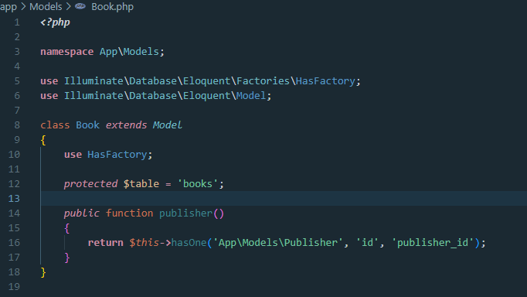

* View

1. **Category Page**

* Route

* Controller

* Model

* View

1. **Publisher Page**

* Route

* Controller

* Model

* View

1. **Contact Page**

* Route

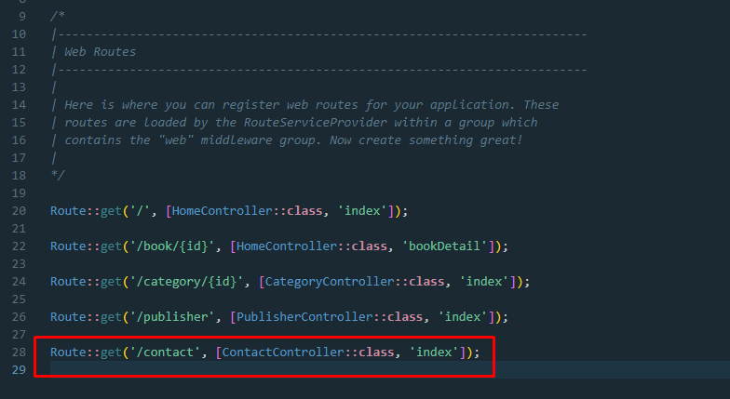

* Controller

* Model

**No Model Needed Since its Static Page**

* View

1. **Migration & Seeder**

**Migration**

**Seeder**

